SIMATS ENGINEERING
Saveetha Institute of Medical and Technical Sciences
Chennai- 602105
Student Name: R.MONIKA
Reg. No:1924260067
Course Code: CSA0801
Slot: C
Course Name: PYTHON


Course Faculty: Dr.U.SAMSON EBENEZAR
Project Title: AUTOMATIC SQL QUERY ERROR DETECTION AND CORRECTION SYSTEM

Module Photographs: (3 photographs –Module Photo, Individual student contribution module work in the project and presentation image)
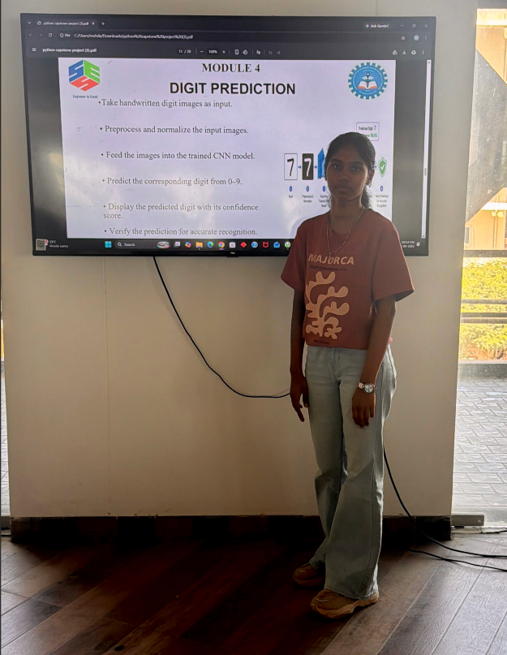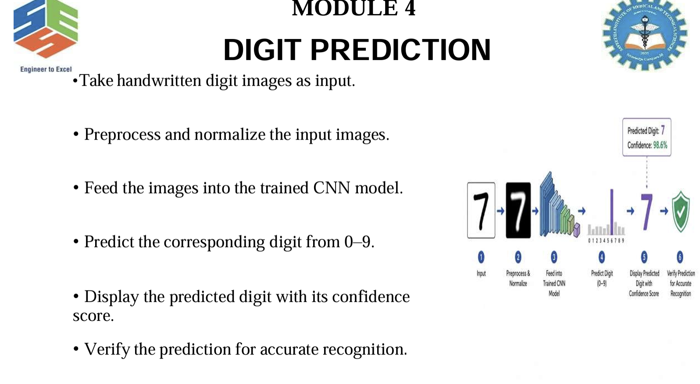
PROJECT DESCRIPTION: MODULE 4: DIGIT PREDICTION
This section describes Module 4: DIGIT PREDICTION, The Digit Prediction module is designed to recognize handwritten digits using the trained Convolutional Neural Network (CNN) model. The user provides a handwritten digit image as input, which is first preprocessed and normalized to make it suitable for the model. The processed image is then passed to the trained CNN, which analyzes the features and predicts the corresponding digit from 0 to 9. The system also generates a confidence score for the prediction and displays the result to the user. This module helps verify the performance of the trained model and demonstrates its ability to accurately recognize new handwritten digit images.

Student Signature :
R.MONIKA Guide Signature

